4.6 Rational Functions and Models
Last time, we went over polynomials:
$f(x) = 4x^{2}+5x-6$ is a polynomial function
$g(x) = x^{1/3}$ is not a polynomial, because the exponent has a fraction

What is a Rational Function?
A rational function is a function of the form:
$f(x) =\frac{P(x)}{Q(x)}$
where:
- P(x) and Q(x) are polynomials.
- Q(x) ≠ 0 (the denominator cannot be zero).
Ex: $f(x) = \frac{x+1}{x^{2}+3x-7}$ is rational function, because both the numerator and the denominator are polynomials.
$g(x) = \frac{x^{1/2}+3}{x^{3}-6x+7}$ is not a rational function, because the numerator is not a polynomial.

Domain of a Rational Function
The domain of a rational function is the set of all real numbers except those values of x that make the denominator equal to zero.
To find the domain:
- Set the denominator equal to zero: Q(x) = 0.
- Solve for x to find the restricted values (the values that cause division by zero).
- The domain is all real numbers except those restricted values.

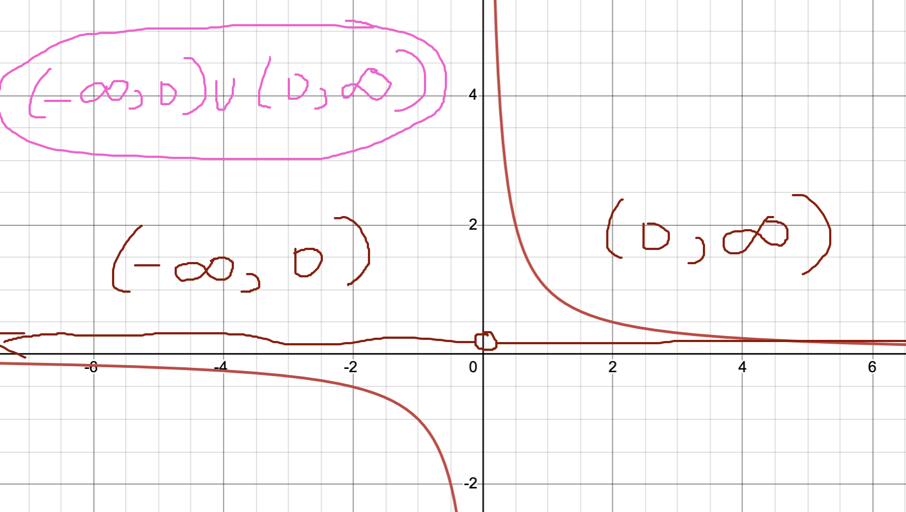

Example: For the rational function $f(x) =\frac{2x + 3}{x^{2} - 4}$:
- Set the denominator equal to zero and solve.
To find the domain, we need to find values for x that would make the denominator equal to zero. These are the numbers that we need to exclude from the domain.
$x^{2}-4=0$, $x^{2}=4$. What this means is that $x=\sqrt{4}=2 or x = -\sqrt{4}=-2$
Square root property says that if we have $x^{2}=k$ then $x=\sqrt{k} or x=-\sqrt{k}$
What does this mean? For our domain, x = 2 and x = -2 are excluded.
In interval notation:
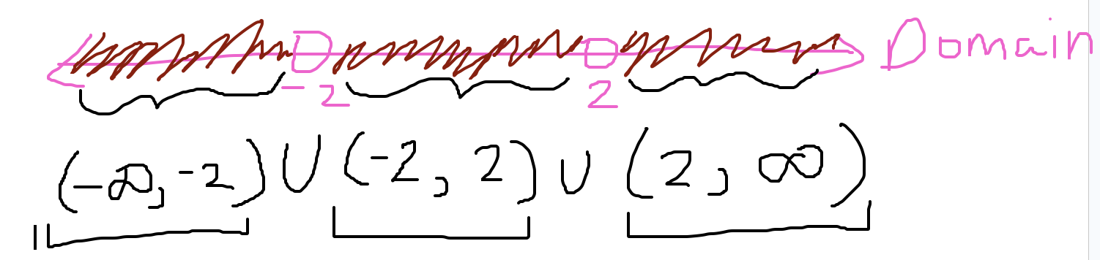
In set notation
{x | x is not equal to -2 or 2}
$\{x | x ≠ 2 or x ≠-2\}$

Identifying Asymptotes
- Vertical Asymptotes
A vertical asymptote occurs where the denominator equals zero, and the numerator is non-zero.
To find vertical asymptotes:
  - Set the denominator equal to zero and solve for x.
- Example:
For $f(x)=\frac{2x+3}{x^{2}-4}$
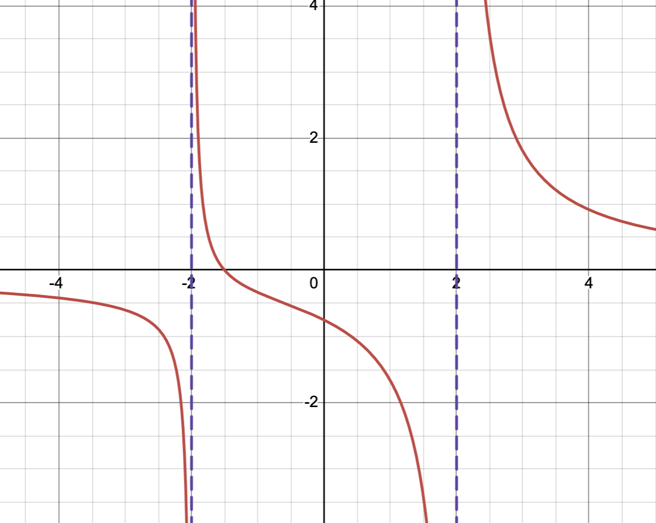
The vertical asymptotes are x = -2 and x = 2
- For $f(x)=\frac{x+2}{x-3}$, what is the vertical asymptote?
The vertical asymptote is x = 3 (the number that makes the denominator zero)

- Horizontal Asymptotes
A horizontal asymptote describes the behavior of a rational function as x approaches positive or negative infinity.
There are three cases:
  - If the degree of the numerator is less than the degree of the denominator, the horizontal asymptote is y = 0.
  - If the degree of the numerator equals the degree of the denominator, the horizontal asymptote is y = (leading coefficient of numerator) / (leading coefficient of denominator).
  - If the degree of the numerator is greater than the degree of the denominator, there is no horizontal asymptote.

Example 1
For $f(x)= \frac{2x^{2} + 3}{x^{2} + 1}$, what is the horizontal asymptote?
degree of the numerator = 2, leading coefficient of the numerator = 2
degree of the denominator = 2, leading coefficient of the denominator = 1

Since the degrees of the numerator and the denominator are the same, then the horizontal asymptote is

$y = \frac{2}{1}=2$
Example 2
For $f(x)= \frac{x^{2}+1}{x-2}$, what is the horizontal asymptote?
degree of the numerator = 2
degree of the denominator = 1
degree of the numerator > degree of the denominator
There is no horizontal asymptote

Example

For $f(x) = \frac{x}{x^{3}+7x+8}$, what is the horizontal asymptote

degree of the numerator = 1
degree of the denominator = 3

degree of the numerator < degree of the denominator

Horizontal asymptote is y = 0.

Break out group questions. Find the horizontal asymptote for each function.

$f(x) = \frac{2}{x+7}$
degree of the numerator = 0
degree of the denominator = 1
degree of the numerator is less than the degree of the denominator
y = 0 is the horizontal asymptote
$g(x) = \frac{x^{3}+9}{x^{2}+7}$
degree of the numerator = 3
degree of the denominator = 2
degree of the numerator is greater than the degree of the denominator
There is no horizontal asymptote
$h(x) = \frac{3x^{3}-8}{2x^{3}+9}$
degree of the numerator = 3
degree of the denominator = 3
since the degrees are the same, the horizontal asymptote is the ratio of the leading coefficients
LC of the numerator = 3
LC of the denominator = 2
$y=3/2$ is the horizontal asymptote.

Review:

Rational function is a function that is a "fraction of polynomials"

$f(x)=\frac{x+2}{x^{2}+6x+5}$

What is a vertical asymptote?

A vertical asymptote involves x values that make the denominator zero. To find a vertical asymptote, we set the denominator equal to zero and solve for x.

How do we find vertical asymptotes?

$x^{2}+6x+5 = 0$
$(x+1)(x+5) = 0$
x + 1 = 0 or x + 5 = 0
x = -1 or x = -5

Our vertical asymptotes are x = -1 and x = -5 (these are vertical lines)

What is a horizontal asymptote?

A horizontal asymptote mirrors how a function behaves when x gets really really big (approaches positive infinity) or really really small (approaches negative infinity). A horizontal asymptote is a horizontal line.

How do we find horizontal asymptotes?

Compare the degrees of the numerator and the denominator.

$f(x)=\frac{x+2}{x^{2}+6x+5}$ degree of the numerator = 1
degree of the denominator = 2
the degree of the denominator is greater than the degree of the numerator.

The horizontal asymptote is y = 0.

Graph:

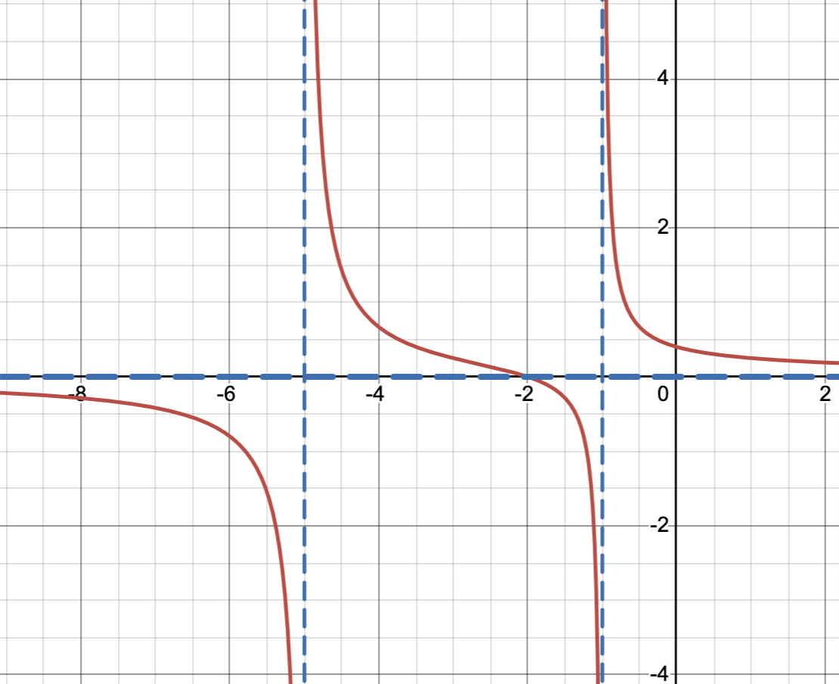

Example:
$h(x) = \frac{x+1}{x^{2}+6x+5 }=\frac{(x+1)}{(x+1)(x+5)}=\frac{1}{x+5}$

In this situation, we only have 1 vertical asymptote, which is x = -5. However, that doesn't mean that the function is defined at x = -1. x = -1 is still not part of your domain.

Graphing Rational Functions Using Transformations
To graph a rational function, we can apply transformations to the basic rational function f(x) = 1/x.
Here’s how we can use transformations:
- Vertical Shift: Adding or subtracting a constant to the numerator or denominator shifts the graph up or down.
- Horizontal Shift: Modifying the denominator (x term) shifts the graph left or right.
- Stretch/Compression: Multiplying the numerator or denominator by a constant will stretch or compress the graph.
- Reflection: Negating the numerator or denominator reflects the graph across the x-axis or y-axis.

Example

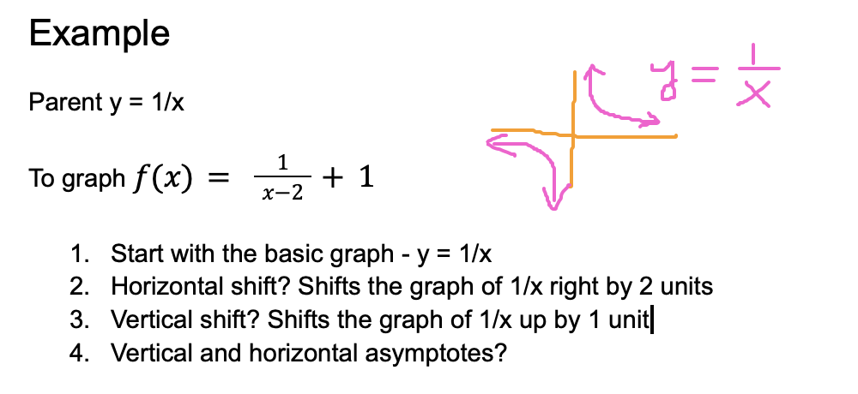
y=1/x, vertical asymptote: x = 0, horizontal asymptote: y = 0

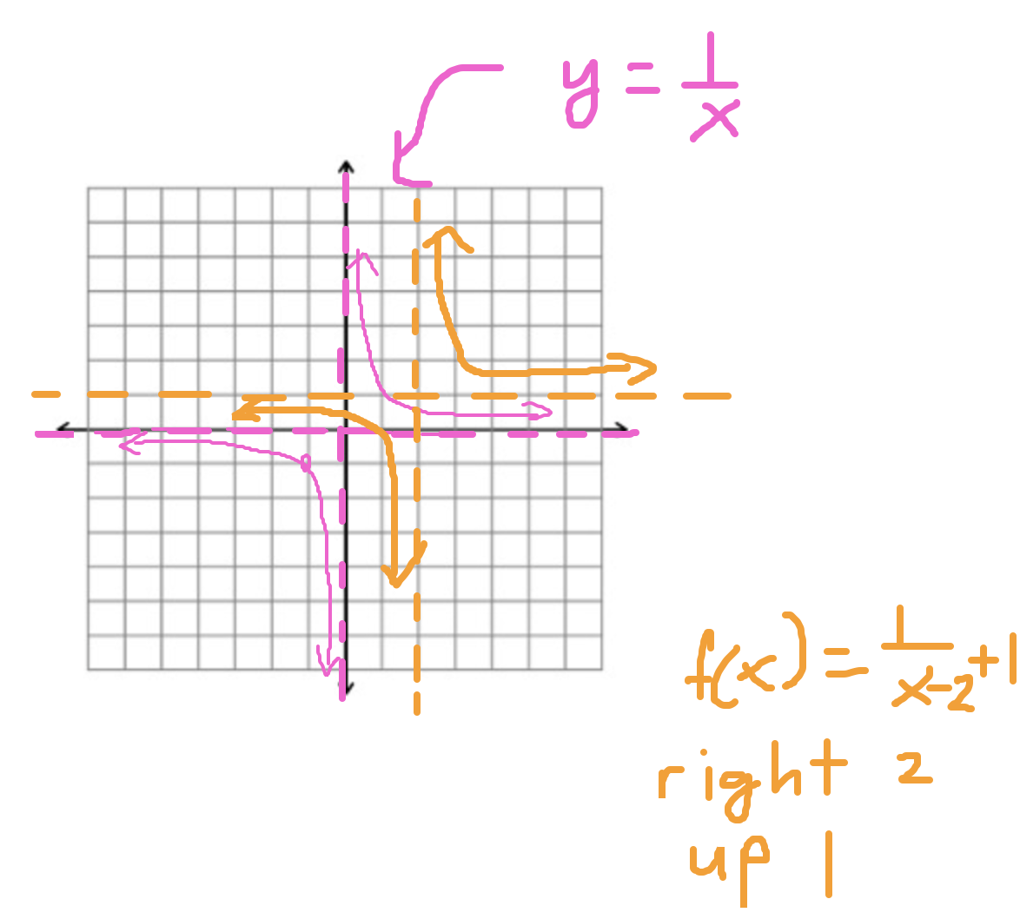

y = f(x-h) if h > 0, then right shift y = f(x-3) right 3 units, y = f(x+3) left 3 units
y = f(x) + k if k > 0, then shift up y = f(x) + 1 up 1 unit, y = f(x) - 1 down 1 unit
y = -f(x), flips across the x-axis

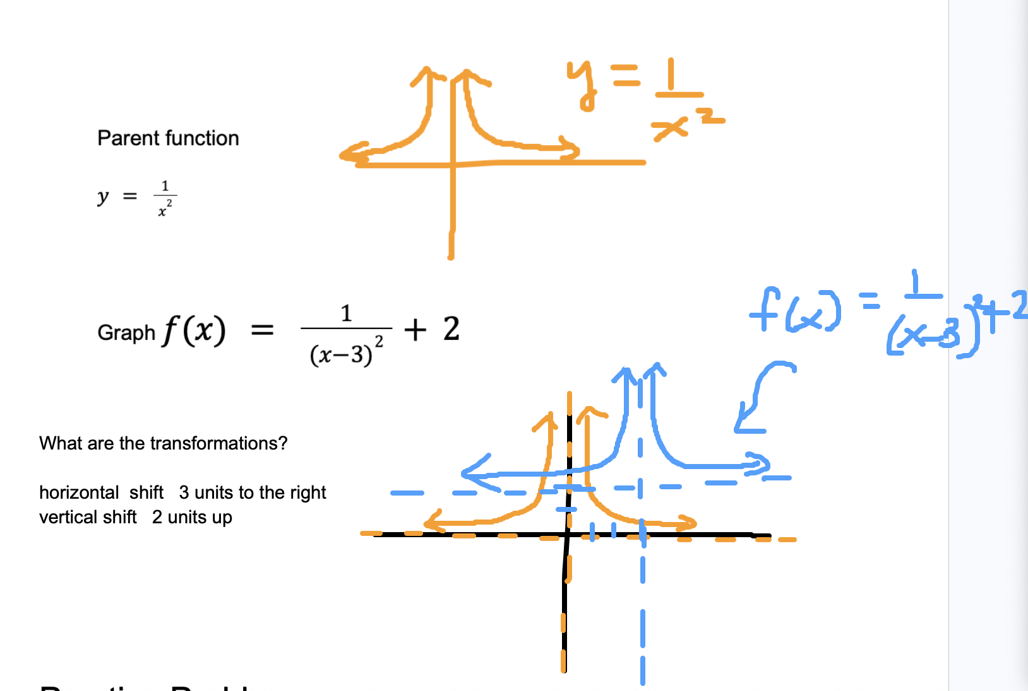

Practice Problems
- Find the domain and asymptotes, and sketch the graph of the following function:
$f(x)= \frac{x^{2}-1}{x^{2}-4}=\frac{(x+1)(x-1)}{(x+2)(x-2)}$
Difference of squares: $A^{2}-B^{2}=(A+B)(A-B)$
$x^{2}-1=x^{2}-1^{2}=(x+1)(x-1)$
$x^{2}-4=x^{2}-2^{2}=(x+2)(x-2)$
  - Find the domain:
We need to find the x-values that would make the denominator 0.
x=-2 or x = 2
{x | x not equal to 2 or -2}
$(-∞,-2)U(-2,2)U(2,∞)$
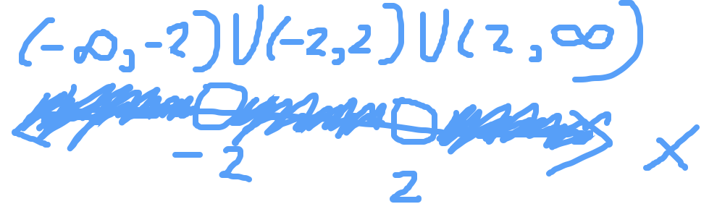
  - Vertical asymptotes:
x = -2
x = 2
  - Horizontal asymptote:
$f(x)= \frac{1x^{2}-1}{{1x}^{2}-4}=\frac{(x+1)(x-1)}{(x+2)(x-2)}$
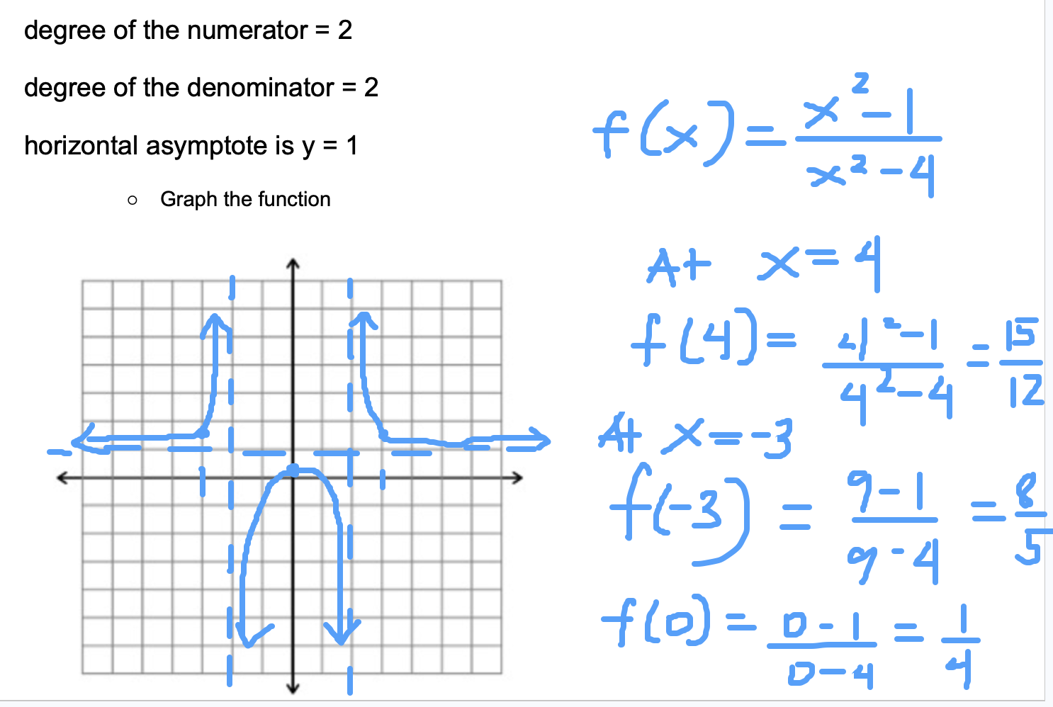

- Find the domain and asymptotes, and sketch the graph of the following function:
$f(x)= \frac{3x+1}{x^{2}-1}$
  - Find the domain:

  - Vertical asymptotes:

  - Horizontal asymptote:

  - Graph the function.
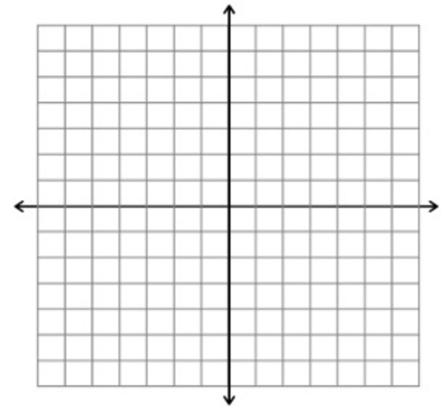

- Graph the following function using transformations:
$f(x)= \frac{1}{x-4}+2$
  - Identify the vertical and horizontal asymptotes.

  - Apply the transformations and sketch the graph.


Key Formulas for Asymptotes
- Vertical Asymptote: Set denominator equal to zero and solve for x.
- Horizontal Asymptote:
  - If degree of numerator < degree of denominator, the asymptote is y = 0.
  - If degree of numerator = degree of denominator, the asymptote is y = (leading coefficient of numerator) / (leading coefficient of denominator).
  - If degree of numerator > degree of denominator, there is no horizontal asymptote.

